Ladies Festival
Saturday February 10th 2018
at
Corby Masonic Complex
Rockingham Road, Corby
Ferraria Lodge 8489
Worshipful Master Scott MacLeod
Who or what is a Ferraria ?
Quite simply the name Ferraria means iron forges, and this inspired the distinctive crest and banner design and represents the development of iron and steel making on which the population growth and prosperity of Corby was based.

*****************************

The lady of our Worshipful Master is running the London Marathon on Sunday, 22nd April 2018 at 10am in aid of “Children with Cancer”
Should you wish to sponsor her per mile or just add to her sponsorship total then a form will be available for you to fill in tonight, alternatively we also have a bucket if you wish to add anything anonymously.

Thank You

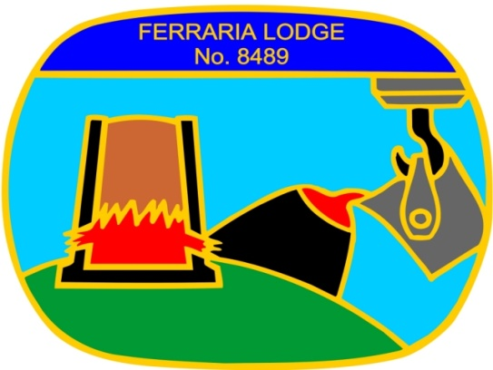

Scott and Dawn extend a warm welcome to you all and hope that you have an enjoyable and happy evening.
Programme for the evening
5.15 Bar opens
5.30 Photographs
5.45 Introduction in the Lodge room to the W.M. and his Lady
6.15 BAR CLOSES
6.45 Please take your seats for Dinner
7.00 Grace
7.05 BAR RE-OPENS
8.15 Toasts, Speeches and Singing
8.45 Interval to re-arrange the Hall/ View Photographs
9.00 Dancing
11.45 Carriages

Our Director of Ceremonies is W. Bro Tom Strickland
The entertainment tonight is provided by ‘POINT BLANK’
Menu

Chicken Liver & Brandy Pate served with a side salad and crusty roll
***
Roast Topside of Beef served with Yorkshire Pudding and Horseradish Sauce
Roast & Skinless New Potatoes, Seasonal Vegetables
***
Triple Chocolate Profiteroles with Ice Cream / Cream
***
Selection of Cheeses and Biscuits
***
Coffee and Tea
After-Dinner Mints

Grace will be Sung
Toasts and Songs
****
Her Majesty The Queen
Proposed by The Worshipful Master
Bro. Scott MacLeod
***

The Ladies
Proposed by W Bro. Barry Ball
***

The Ladies Song
(Gentlemen please stand and sing to your Ladies)
Led by W Bro.Sam Hagen
***

Response
Mrs. Dawn MacLeod
***

The Tylers Song
Led by “The Choir “ assisted by the Audience!!

***
Masonic Grace

For these and all Thy mercies given
We bless and praise Thy name O Lord
May we receive them with thanks-giving
Ever trusting in Thy Word
To Thee alone be honour, glory
Now and henceforth for evermore

The Ladies Song

Ladies from the East and West, We have done our very best
To ensure your welcome here, Bright, Fraternal, and Sincere

Chorus
Warm Masonic hearts to meet you, Hands of Fellowship to greet you
May our welcome here today, Cheer each Lady on her way

Repeat Chorus (All Gentlemen)

We all recognise your worth, Our best friends upon this earth
May we always be inclined, To be loving, true and kind
Chorus (Solo)
Repeat Chorus (All Gentlemen)

When on earth we say “Adieu”, May our love remain with you
And may we renew that love, In a Grander Lodge above

Chorus (Solo)
Repeat Chorus (All Gentlemen)

The Tylers Song

Are your glasses all charged in the West and the South?' the Worshipful Master cried!
'All charged in the West'
'All charged in the South'
Came the Wardens' prompt reply Then to our final toast tonight, our glasses freely drain,
Happy to meet, sorry to part, happy to meet again.

Chorus
Happy to meet again
Happy to meet again
Happy to meet sorry to part
Happy to meet again

Amidst our mirth we drink to all
Our Brethren o'er the Earth,
In every clime our flag of love is gloriously unfurled.
We prize each Brother, dark or fair who bears no moral stain,
Happy to meet, sorry to part, happy to meet again.

Repeat Chorus

To brethren of the mystic tie, the night is waning fast,
Our feast is o'er, Our work is done this toast must be the last.
Good night to all, once more , once more,
repeat the farewell strain,
(Response)
Happy to meet, sorry to part, happy to meet again.

Repeat Chorus

Scott and Dawn wish you all a safe journey home and
hope you have enjoyed tonights festival.

***
Happy have we met,
Happy may we part,
And happy to meet again.

***

The Masonic Complex is active on the Internet and on Social Media.

So be sure to look out for photos taken tonight on our website.

Website : www.corbymasoniccomplex.co.uk

Facebook : Corbymasons

Twitter : @corbymasons

If you are interested in hiring the complex for your own event then please take a look at www.corbyweddingsandfunctions.co.uk

