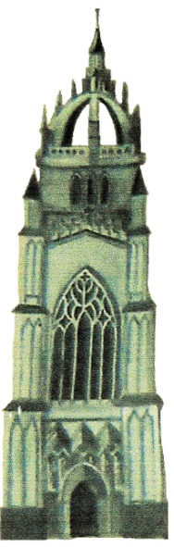 |  | The Worshipful Master & his Lady of The Lodge of St Giles No 8736  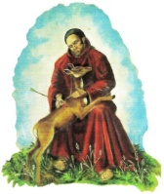 |  |  |  |  |  | 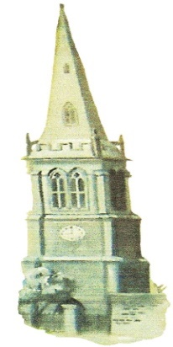
Cordially invite you & your Lady to their
Ladies Festival
At the Masonic Complex, Rockingham Road, Corby
on Saturday 11th May 2019
Reception 5.15pm – Dinner at 6.45pm prompt, Late Bar

Dancing to
John Burrows Band

Tickets: £32.00 each  Closing Date: Friday 3rd May2018  Numbers may be limited  .............................. |  |  |  | Cocktail or Evening Dress  Dinner Suits or Highland Attire  Regalia without Jewels, No Gloves
Please complete & return this slip:
Please reserve me tickets for the Lodge of St Giles Ladies Festival on 11th May 2019
 |  |  | Number of Tickets Required
Title | Christian Name |  | Surname |  | Rank |  | Dietary needs
Please continue overleaf for further guests & advise of any special dietary requirements
Cheques should be made payable to Lodge of St Giles Ladies Festival,
BACS Transfer: 40-36-15 42240823
Response to Milan Crooks c/o Masonic Complex, Rockingham Rd, Corby, NN17 1AD, email: stgiles8736@icloud.com

